

**Generation of Mesenchymal Stromal Cell Precursors in a 3-D Hollow Fiber Placenta Co-Culture Model**

*John J.S Cadwell, CEO FiberCell Systems® Inc.*

# Mesenchymal Stromal Cells

Mesenchymal stromal cells (MSC) are multipotent adult stem cells that are present in multiple tissues, including umbilical cord, bone marrow and adipose tissue. Mesenchymal stromal cells can self-renew by dividing and can differentiate into bone, cartilage, muscle, adipocytes, and connective tissue. The therapeutic potential of MSC and their extracellular vesicle secretome is an area of intense study. Due to the diversity of characteristics displayed by MSCs from different sources by various isolation methods, the ISCT (International Society for Cell and Gene Therapy) recommended these minimal criteria to define MSCs: (1) cell adhesion and proliferation on a plastic surface, (2) specific positive and negative surface markers and (3) in vitro tri-lineage differentiation capability. One significant drawback to the use of 2-D culture systems is the limited number of passages that can be performed before the MSC begin to differentiate.

Figure 1: Cartridge and Fibercell Systems duet will fit into any laboratory incubator.

The unequivocal identification of MSCs *in vivo* has been hampered by their extremely low frequency in tissues and the lack of a distinct MSC-specific immunophenotype to enable their identification and isolation. Cultured MSC do express a panel of cell surface markers such as CD73, CD105, CD90 and lack endothelial or hematopoietic cell markers (CD34, CD31 and CD45). Nevertheless, these markers are not homogeneously expressed throughout stromal cultures, vary with isolation protocols and passage number, and therefore are not necessarily representative of MSCs *in vivo*. The microenvironment for MSC *in vivo* is clearly quite different from 2-D flask culture, but unfortunately 2-D flask culture is part of the working definition for MSC identification.

# 3-D Artificial Capillary Hollow Fiber Bioreactors vs. T-Flasks

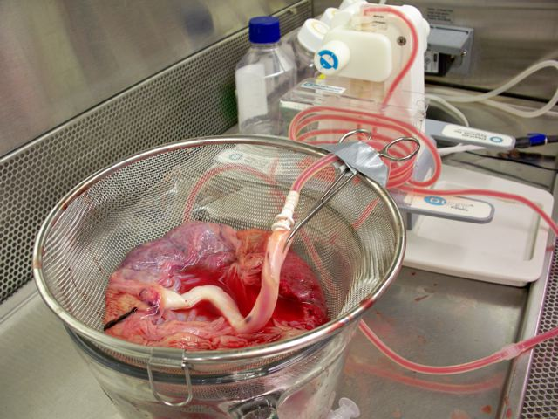3-D hollow fiber artificial capillary bioreactors present a more *in vivo* like microenvironment to cells in culture. The tremendous surface-area-to volume-ratio allow cells to be cultured at *in vivo* like cell densities, 1-2X10e8/ml. Cells are bound to a porous support, not a non-porous 2-D plastic surface, so cells do not require splitting or passaging. Cell-to-cell interactions have time to fully develop. The molecular weight cut-off (MWCO) of the fibers helps control the composition of the micro-environment and concentrates secreted autocrine factors and biological products around the cells. An issue with MSC relative to 3-D hollow fiber bioreactors is that part of their very definition is that MSC bind to 2-D plastic cell culture flask surfaces and proliferate. The binding of cells to a porous hollow fiber is different than attachment to 2-D plastic surface and this is reflected in how MSC behave in 3-D hollow fiber bioreactors. MSC in a 3-D hollow fiber bioreactor are in an environment that more closely recapitulates their *in vivo* environment, and they should behave differently, and more *in vivo*-like than in 2-D flask culture.

Figure 2: FiberCell Systems Duet pump was used to provide pulsatile perfusion of the placenta for both the perfusion with PBS and the digestion with collagenase.

# Human Placenta as a Source of Stem Cells for 3-D Culture

One interesting source of MSC is the human placenta. Postpartum placentas have a variety of advantages including easy acquisition and few ethical considerations. Placental cells are also "immunologically naïve," reducing the incidence of Graft Versus Host Disease in therapeutic applications. If the 3-D structure of a placenta were reconstituted inside a hollow fiber bioreactor it could result in the formation of an *in vitro* placenta model. To test this hypothesis a fresh placenta was perfused with phosphate buffered saline and then digested with collagenase Type II for one hour. The collected heterogeneous cell mixture, representing all the different cells present in a placenta, including endothelial cells, were harvested and seeded into a hollow fiber bioreactor module, FiberCell Catalog number C2008, 5 kD MWCO. The mixed cell population derived in this way from whole placenta is a co-culture containing all the elements of an intact placenta that may be able to mimic its structure and function. The placenta is a rich source of various types of stem cells and has the advantage of being only 9 months old as opposed to adult derived stem cells. Both the 3-dimensional matrix, and the concentration of autocrine factors afforded by the 5 kD MWCO fiber may be supporting the *de novo* generation of a stem cell types as they are normally produced *in vivo*.

Figure 3: Suspension cells harvested from the ECS were plated into T75 flasks with serum containing medium. Proliferating cells and spheroids were noted.

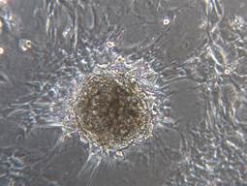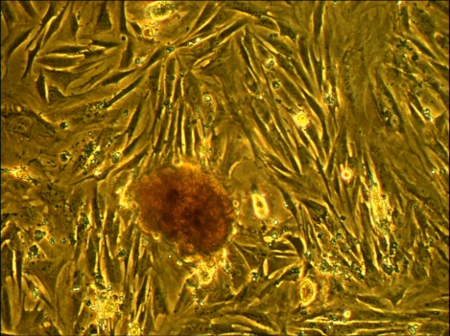

# Materials and Methods

A normal intact human placenta was sourced from a local hospital under conditions approved by the Institutional Review Board (IRB). The umbilical vein was cannulated, and a solution of PBS perfused for one hour. After one hour at room temperature the solution was changed to PBS containing one gram per liter of collagenase type II (Worthington Biochemicals, Lakewood, New Jersey). This was perfused for 2 hours at room temperature. The placenta was digitally disaggregated, and the cells in the perfusate were collected, washed once in cell culture medium and the red cells removed using ACK lysing buffer (Quality Biologicals catalog number 118-156- 101). Cells were washed once more in cell culture medium. Total number of viable cells was difficult to establish due to the significant amount of cell debris and red cells still present. 20 ml of the cell isolate (out of a total of 40 ml) was seeded into a FiberCell® Systems C2008 5 kD MWCO polysufone cartridge and the culture initiated with 100 ml of DMEM/F12 + 10% FBS and 2% pen/strep at a flow rate of 60 ml/minute. On day 2, day 3 and day 5 the ECS (extracapillary space) was washed with cell culture medium to remove any non-adherent cells. Starting with day 10 the cells from the ECS were harvested, photographed under a microscope and plated into 6 well dishes every three days. The cartridge remained viable, consuming glucose for over three months of continuous culture. The culture was then terminated. The initial glucose uptake rate was around 100 mg/day. By day 10 this had increased to a level of A picture containing indoor, cloth
250-350 mg/day where it remained in a fairly steady state throughout the remainder of the culture period. As the harvests progressed the amount of cell debris noted was reduced. Significant cell numbers were collected with each harvest and most interestingly, clusters of cells that resembled spheroids, in significant numbers, were also harvested. The number of spheroids harvested did not decrease over time. When these harvests were placed into flask culture, a certain population of cells would attach to the plastic while the spheroids remained intact and also attached to the flask.

Figure 4: 7-10 days after the inoculation of cells and the removal of non-adherent cells red nodules would begin to form on the surface of the fibers. Cartridge shown below is after 30 days of culture.

# Harvested Suspension Cells show MSC Phenotype When Plated in Flasks

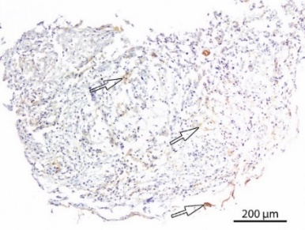In a hollow fiber bioreactor, the 3-dimensional geometry, long term culture without cell passaging, and the concentration of secreted cytokines are all factors that support the *de novo* generation of stem cell types as they are produced *in vivo*. After 7-10 days of culture the formation of red nodules on the surfaces of the fibers were observed. (Figure 1) The harvests from the ECS (extra-capillary space) performed every three to four days over a period of three months showed very few normal sized nucleated cells, but numerous cells of smaller diameter. It is important to note that these cells were truly suspension cells, the ECS was simply drained and then refilled with fresh medium. When the harvested suspension cells were plated into a flask with serum containing medium a confluent cell layer developed within 4 days indicating rapid growth. Also noted were numerous spheroids on the surface of the culture (Figure 2). The susp ension cells harvested from the cartridge initially showed a fairly non-specific phenotype (Table 1) However, after culture in the flask the phenotype shifts profoundly to that of MSC when examined by flow cytometry. These cells that initially showed a non-distinct cell surface marker profile and growing in suspension now stained strongly for MSC markers (96% +) while adhering to the plastic surface of the flask and proliferating. This demonstrated a change in phenotype by the 2-D flask culture conditions versus the initial suspension ECS harvest. Based upon these observations this placental co-culture is continuously producing suspension precursors of MSC in significant numbers that become classically defined MSC when placed in 2-D flask culture.

Figure 5: Cross-section of nodules at 10X and 40X magnification

One cartridge produced viable flask cultures from the ECS harvests for over three months. In general, as harvests from the ECS progressed over time the amount of cell debris (presumed to be from non-viable cells and/or residual placental tissue) was reduced. Significant cell numbers (on average, 1 x 106) were extracted from the cartridge every 2-7 days. Aggregates of cells that resemble spheroids were also harvested from the cartridge throughout the continuous 3 months of culture.

|  |  |  |
| --- | --- | --- |
| **Phenotype** | **ECS Harvested** | **Flask Cultured** |
| CD45 | 4% | 1% |
| CD 34 | 0% | 0% |
| CD133/2 | 2% | 0% |
| CD31 | 3% | 48% |
| CD13 | 6% | 83% |
| CD105 | 43% | 99% |
| CD73 | 18% | 99% |
| CD90 | 5% | 96% |
| CD14 | 23% | 4% |
| NANOG | 0% | 0% |
| OCT3/4 | 18% | 13% |

**Table 1:** Cells harvested from the ECS of the hollow fiber bioreactor compared with the phenotype of these cells after 3-5 days of culture in flasks with serum containing medium. This demonstrates the differences in cell phenotype of 3-D hollow fiber vs. 2-d flask culture conditions. Note the almost total conversion to mesenchymal stem cell markers CD105, CD73 and CD 90, the increase in CD13, an endometrial stromal cell marker, and the increase in CD31, and endothelial cell marker. OCT3/4, sometimes a marker for undifferentiated cells is still present. There were two populations of cells present, the adherent layer and the spheroids growing on top of this layer. They were not separated for this assay.

# Conclusion/Discussion

These data and observations indicate that a mixed cell population derived from a human placenta, when seeded into a hollow fiber bioreactor, remains viable for several months, spontaneously forms 3-dimensional nodular structures, and continuously generates suspension cells of non-defined phenotype that subsequently show MSC phenotype and proliferation when seeded into 2-D cell culture flasks. Intact spheroids are also present in this harvest. Furthermore, large spheroids form on the surface of fibers, the likely site of MSC precursor production. Cross sections of these nodules are shown in Figure 4. The inference is that these suspension cells harvested from the ECS of the bioreactor represent either MSC precursors or MSC as they are found *in vivo*.

3-D hollow fiber bioreactors provide a unique cell culture environment that closely recapitulates the *in vivo* microenvironment. Cells are in close proximity, secreted autocrine factors are concentrated, and cells dot not require splitting so that cell-to-cell interactions are enhanced and allowed to develop over time. There are other instances of this concept being applied to liver and gut, for example. In this case an *in vitro* placenta model was shown to be a potential source of MSC progenitor cells and could be maintained for several months of continuous collection. This 3-D placenta co-culture model could provide insight into the biogenesis and in vivo characteristics of mesenchymal stromal cells.

# Suggested references

1. “Bioreactors for Extracorporeal Liver Support” Gerlach, J.C. Cell Transplantation, Vol. 15, Supplement 1, pp. S91-S103 2006
2. “Placenta Perfusion has Hematopoietic and Mesenchymal Progenitor Stem Cell Potential” Tsagias, N. et al Transfusion, Vol I, pages 1-9
3. Very small embryonic-like stem cells (VSELs) regenerate whereas mesenchymal stromal cells (MSCs) rejuvenate diseased reproductive tissues. Bhartiya D, Singh P, Sharma D, Kaushik A. Stem Cell Rev Rep. 2021 Aug 19. doi: 10.1007/s12015-021-10243-6. Epub ahead of print. PMID: 34410593.
4. “3-Dimensional Cell Culture in Hollow Fiber Bioreactors” Cadwell, J.J.S.
5. [FiberCell-Systems-3-Dimensional-Cell-Culture-in-Hollow-Fiber-Bioreactors-.pdf (fibercellsystems.com)](https://www.fibercellsystems.com/wp-content/uploads/2017/09/FiberCell-Systems-3-Dimensional-Cell-Culture-in-Hollow-Fiber-Bioreactors-.pdf)
6. “The Hollow Fiber Bioreactor and Cell Co-Cultivation” Cadwell, J.J.S. American Laboratory June 2012
7. “Hollow Fiber Bioreactor Protocol for Mesenchymal Stem Cells” FiberCell Systems, 2021 [FiberCell-Systems-Hollow-Fiber-Bioreactor-Protocol-for-Mesenchymal-Stem-Cells.pdf (fibercellsystems.com)](https://www.fibercellsystems.com/wp-content/uploads/2021/10/FiberCell-Systems-Hollow-Fiber-Bioreactor-Protocol-for-Mesenchymal-Stem-Cells.pdf)
8. [Article-The-Hollow-Fiber-Bioreactor-and-Cell-Co-Cultivation.pdf (fibercellsystems.com)](https://www.fibercellsystems.com/wp-content/uploads/2015/07/Article-The-Hollow-Fiber-Bioreactor-and-Cell-Co-Cultivation.pdf)
9. “Three-dimensional Cell Based Assays in Hollow Fibre Bioreactors” Cadwell, J.J.S. and Whitford, W.G. (Book Chapter) Technology Platforms for 3-D Culture, a User’s Guide. John Wiley and Sons 2017
10. Hollow-fiber bioreactor production of extracellular vesicles from human bone marrow mesenchymal stromal cells yields nanovesicles that mirrors the immuno-modulatory antigenic signature of the producer cell: Gobin, J. et al. Stem Cell Research and Therapy(2021) 12:127
11. Three-dimensional culture of MSCs produces exosomes with improved yield and enhanced therapeutic efficacy for cisplatin-induced acute kidney injury: Cao et al; Stem Cell Research and Therapy (2020) 11:206
12. Effective enrichment of cholangiocarcinoma secretomes using the hollow fiber bioreactor culture system: Weeraphan, C.; Talanta. 2012 Sep 15;99:294-301
13. High density Huh7.5 cell hollow fiber bioreactor culture for high-yield production of hepatitis C virus and studies of antivirals: Pihl, A. et al., Nature Scientific Reports volume 8, Article number: 17505 (2018)

The author would like to acknowledge the contributions of James H. Hardy to this article.